**BALLARPUR INSTITUTE OF TECHNOLOGY**

**BALLARPUR – 442701**



**A Project Report on**

**“ A Home Plant Wikipedia**

**The GreenYard ”**

**DEPARTMENT OF UNDER-GRADUATE STUDIES IN**

**BACHELOR OF ENGINEERING**

**COMPUTER SCIENCE AND ENGINEERING**

***Submitted by***

**Mr. Lovely Sharma (PRN NO - 2141881242502)**

**Mr. Sahil Chaudhari (PRN NO - 2041881242033)**

**Mr. Bhaskar Tikale (PRN NO - 2141881242516)**

**Mr. Ritesh Zode (PRN NO - 2041881242029)**

**V Semester**

**Under the Guidance of**

**Prof. Deepali Khatwar**

**(Department of Computer Science & Engineering)**

**DR. BABASAHEB AMBEDKAR TECHNOLOGICAL UNIVERSITY, LONERE**



**Session 2022-23**

**BALLARPUR INSTITUTE OF TECHNOLOGY**

**BALLARPUR – 442701**

**DEPARTMENT OF COMPUTER SCIENCE AND ENGINEERING**



**CERTIFICATE**

This is to certify that the project work on **“A Home Plant Wikipedia – The GreenYard”** is a bona fide work carried out by **Mr. Lovely Sharma (PRN NO-2141881242502), Mr. Sahil Chaudhari (PRN NO - 2041881242007), Mr. Bhaskar Tikale (PRN NO - 2141881242528), Mr. Ritesh Zode (PRN NO - 2141881242522)**in partial fulfillment of the requirement for the award of degree of Bachelor of Engineering in the department of **Computer Science and Engineering**, offered by the **Dr. Babasaheb Ambedkar Technological University, Lonere,** during the academic year **2022-2023**. It is certified that all corrections/suggestions indicated have been incorporated in the report deposited in the departmental library. The report has been approved as it satisfies the academic requirements in respect of prescribed for the Bachelor of Engineering.

**Prof. Deepali Khatwar Prof. Hirendra Hajare Prof.Hirendra Hajare**

**Guide B.Tech. Coordinator HoD**

**Dept. of CSE Dept. of CSE Dept. of CSE**

**Dr. Rajni Kant**

**Principal**

**Name of the Examiners Signature with Date**

1. ---------------------
2. ---------------------

**ACKNOWLEDGEMENT**

With immense pleasure and great respect I take this opportunity to express my deep sense of gratitude toward my guide, **Prof. Deepali Khatwar,** Assistant Professor, Department of Computer Science and Engineering, B.I.T Ballarpur for invaluable guidance, inspiration, constant encouragement and motivation throughout the project work.

I am thankful to **Prof. Hirendra R. Hajare** Assistant Professor, B.E. Coordinator Department of Computer Science and Engineering, B.I.T Ballarpur who helped me to understand basic methodologies of my project.

I am grateful to **Prof. Hirendra R. Hajare**, Head of Department, Department of Computer Science and Engineering, B.I.T Ballarpur and all the faculty of department Computer Science and Engineering, B.I.T, Ballarpur for providing the amicable environment and allowing me to use available facilities in this department during the course of this study.

We thank to **Dr. Rajni Kant** our beloved Principal, B.I.T Ballarpur for his encouragement and providing all facilities needed in our project.

I am very thankful to my friend and well-wisher who directly or indirectly helped me at every stage to complete this work.

Last but not least, I would like to thanks my family and almighty without their good wishes and blessing this dissertation work could not have been completed.

Mr. Lovely Sharma (PRN NO - 2141881242502)

Mr. Sahil Chaudhari (PRN NO - 2041881242033)

Mr. Bhaskar Tikale (PRN NO - 2141881242516)

Mr. Ritesh Zode (PRN NO - 2041881242029)

**DECLARATION**

I hereby declare that

1. The work contained in this dissertation has been done by me under the supervision of my Guide.
2. The work has not been submitted to any other Institute for any degree or diploma.
3. I have followed the guidelines provided by the Institute in preparing the project report.
4. I have conformed to the norms and guidelines given in the Ethical Code of Conduct of the Institute.
5. Whenever I have used materials (data, theoretical analysis, figures, and text) from other sources, I have given due credit to them by citing them in the text of the report and giving their details in the references. Further, I have taken permission from the copyright owners of the sources, whenever it is necessary.

Mr. Lovely Sharma (PRN NO - 2141881242502)

Mr. Sahil Chaudhari (PRN NO - 2041881242033)

Mr. Bhaskar Tikale (PRN NO - 2141881242516)

Mr. Ritesh Zode (PRN NO - 2041881242029)

**INDEX**

**Abstract**………………………………………………………………………………………… 6

**List of Figures**………………………………………………………………………………… 7

**Chapter 1 Introduction**

* 1. Background ………………………………………………………………………. 8
  2. Aim ……………………………………………………………………………….. 8
  3. Motivation ……………………………………………………………………….. 9
  4. Proposed Work …………………………………………………………………... 9

**Chapter 2 Literature Review**

2.1 Review of different Method …………………………………………………… 10

2.2 Concluding Remark ………………………………………………………………. 10

**Chapter 3 Proposed Works**

3.1 Purpose …………………………………………………………….………….…11

3.2 Key features…………………………..………………………………………… 11

3.3 Design & Interface…….………………………………………………………... 12

3.4 System Modeling………………………………………………………………….12

**Chapter 4 Research Methodology**

4.1 The Waterfall Model ……………………………………………………………... 13

4.2 Design Goals ……………………………………………………………………… 14

**Chapter 5 Project Design**

5.1 Front and Backend......…………………………………………………………. 15

5.2 Architectural Diagrams…………………………………………………………..18

5.3 Project Code …………………………………………………………………… 23-25

**Chapter 6 Result**

6.1 Snapshots ………………………………………………………………………. 26-28

**Chapter 7 Conclusion**

7.1 Conclusion ………………………………………………………………………… 29

7.2 Scope of future work ……………………………………………………………… 29

**Chapter 8 Hardware and Software requirements**………………………………………….. 30

**Chapter 9 References**……………………………………………………………………….. 31

**ABSTRACT**

The project aims to build a website which assists it's user by providing necessary information about home plants. The users can register themselves to the website and upon successful registration they can login to view the plants information which other people has posted. The users can easily upload new plant information and make it public for the audience.

The plant information will be listed in the form of tiles, and whenever a user clicks on a particular tile it should open the entire plant information on a new page where a normal user can read the information.   
Along with this if they wish to share the information they can download it in the form of pdf and share it with others. The users who have contributed to the website by providing necessary information can view their posts and make changes if they want.

Our website is a comprehensive resource for anyone interested in caring for home plants. We cover a wide range of plant types, from succulents to ferns, and provide detailed information on how to care for each one. Our website also features stunning photos of each plant, making it a visually appealing resource for plant lovers. Whether you're a beginner or an experienced plant parent, you'll find valuable information on our website.

**LIST OF FIGURES**

|  |  |  |
| --- | --- | --- |
| **SR.**  **NO** | **FIGURES** | **PAGE**  **NO** |
| **1** | User Use Case | 18 |
| **2** | Admin Use Case | 19 |
| **3** | ER Diagram | 20 |
| **4** | SQL Structure | 21 |
| **5** | User/Admin Flowchart | 22 |

**Chapter 1**

**INTRODUCTION**

* 1. **Background**

Plants are a diverse group of living organisms that are characterized by their ability to photosynthesize and produce their own food using energy from sunlight. They are the primary source of food and oxygen for most life on Earth, and they play a vital role in the ecosystem by providing habitat and resources for other organisms.

Plants play a vital role in the ecosystem and have a wide range of uses for humans, including food, medicine, and ornamental purposes. However, despite their importance, there is still much that we do not know about the biology, ecology, and evolution of plants.

The topic of my research is the category of home plants. While there has been some research in this area, the knowledge base is still limited and there is a need for more comprehensive and in-depth studies.

The significance of this research lies in its potential to improve our understanding of the diversity and function of plants, their proper usage and excellent utilization and to inform the development of sustainable and effective plant-based solutions for a range of challenges facing society.

* 1. **Aims and Objectives**

1. To design and develop a web application which bridges the gap between a common user and the vast pool of information that is available over the internet about the home plants by providing a platform with everything at one place.
2. To improve the user experience of the website by updating the design and layout, simplifying the navigation, and incorporating responsive design for mobile devices within the next three months.
3. To increase online sales by 10% over the next year through the implementation of an effective e-commerce platform and the development of a comprehensive online marketing strategy.
   1. **Motivation**

The topic of my research is to provide the genuine information about the plant as they could be useful in the use of plant-based medicine for the treatment of multiple health conditions. Plant-based medicine has a long history of use in traditional and alternative healthcare systems, and many people turn to these treatments as a natural and potentially safer alternative to conventional medicine.

There is a need for more comprehensive and rigorous research to better understand the potential benefits and risks of these treatments.

1. Review the existing literature on the project and other relevant information.
2. Investigate the mechanisms through which the project could help improve gardening practices.
3. Investigate the mechanisms through which plant-based treatments may impact different health conditions.
   1. **Proposed Work**

The study will use existing data available over the internet to collect data on different home plants. The data will be analyzed using Statistical techniques to investigate the relationship between variables of interest.

Data collection will involve data collection methods such as web scraping. Data analysis will be done on it using python and other data analysis tools.

Potential challenges that may arise during the study, which will be addressed by different strategies to address challenges. Ethical considerations will be addressed by obtaining Ethical approval and obtaining informed consent from all participants.

**Chapter 2**

**LITERATURE SURVEY**

* 1. **Literature Survey**

Subjective questionnaires on the comfort sensation and satisfaction degree as well as objective physiological measurements were made in different conditions (office with different plants or without any plants). The following conclusions can be drawn.

1. The high satisfaction degree and comfort sensation demonstrate that an environment with plants can effectively improve human comfort.
2. The environment assessed to be the most comfortable condition was the one with green, slightly scented and small-size plants.
3. The EEG and oxyhaemoglobin saturation in selected six physiological indexes (EEG, ECG, oxyhaemoglobin saturation, fingertip blood flow, skin resistance.
4. Larsen L, Adams J, Deal B, et al. Plants in the workplace—the effects of plant density on productivity, attitudes, and perceptions. Environ Behav 1998; 30: 261–281.
5. Han KT. Influence of limitedly visible leafy indoor plants on the psychology, behavior, and health of students at a junior high school in Taiwan. Environ Behav 2009; 41: 658–692.
6. Roelofsen P. The impact of office environments on employee performance: the design of the workplace as a strategy for productivity enhancement. J FacilManag 2002; 1: 18.
7. Wells M. Office clutter or meaningful personal displays: the role of office personalization in employee and organizational wellbeing. J Environ Psychol 2000; 20: 17.
8. Conklin E. Interior plantings bring nature indoors. Amer Nurseryman 1974; 139: 10.
   1. **Concluding Remarks**

The Plant Information Website will provide a valuable resource for anyone interested in plants, offering a wealth of information and helpful resources in a user-friendly format. It will be an essential tool for gardeners, horticulturists, and anyone else seeking reliable and up-to-date information about plants.

**Chapter 3**

**PROPOSED WORK**

**3.1 Purpose:**

The purpose of this website is to provide a comprehensive source of information about plants, including details about the appearance, habitat, and care requirements of each plant. The website aims to meet the needs of a wide range of users, including gardeners, horticulturists, botanists, and anyone else with an interest in plants.

Intended Audience: The intended audience for this website includes people of all ages and genders who have an interest in plants. This includes gardeners, horticulturists, botanists, and anyone else who is looking for reliable and up-to-date information about plants.

**3.2 Key Features:**

* A database of plant information, including details about the appearance, habitat, and care requirements of each plant.
* A plant search function, allowing users to find plants based on specific criteria such as scientific name, common name, or region of origin.
* Plant identification tools, including a plant identification quiz and a plant identification guide.
* Plant care tips and advice, including information on watering, fertilizing, pruning, and other aspects of plant care.

**3.3 Design and User Interface:**

The design of the website will be visually appealing, with clear and easy-to-navigate menus and pages. The user interface will be intuitive and user-friendly, with clear instructions and helpful illustrations.

**3.4 Proposed Method for Development:**

The website will be developed using **PERN** stack which consists of developing the front end using basic technologies such as **HTML**, **CSS**, and **JavaScript**. Along with this in order to provide a smooth user experience the project also uses **jQuery** and **Ajax** for performing asynchronous database operation.

The project is backed by Node framework which is a runtime environment based on **JavaScript** , it also express framework which provide greater functionalities to develop a new web application with all required features

In order to provide the database operation service we are using **PostgreSQL** as our database system which a free and open source database management system.

A Content Management System (**CMS**) such as **PgAdmin** is used to manage the database of plant information and allow for easy updates and additions. The development process will involve designing and coding the website, populating the database with plant information, and testing and debugging the website to ensure it is fully functional.

**3.5 Modeling:**

The Project is divided into certain module which helps in development of the project with ease.

* User Signup Module
* User Login module
* Dashboard module
* Admin Login module
* Admin content management module

The exact working of all these modules is described in the next section.

**Chapter 4**

**RESERCH METHODOLOGY**

**4.1 The Waterfall Model**

The waterfall methodology is a linear project management approach, where stakeholder and customer requirements are gathered at the beginning of the project, and then a sequential project plan is created to accommodate those requirements.

The most important phases of the waterfall model can start functioning as follows:

1. Analysis:

This phase will be tasked with gathering all the information available on past year question papers and devising the different parameters that’ll be used for determining helpful website for the students.

1. Design:

In this example of the waterfall model, the design phase is all about fine-tuning the parameters established in the analysis phase and making sure that the structure of the software program is precise enough to avoid any manipulation of or confusion over large volumes of data.

1. Implementation:

This all-important phase involves doing dummy runs of the website program with a provisional set of data to see the accuracy with which the program can give the relevant question sets to students.

1. Testing:

As with any example of the waterfall model, the testing phase is about ensuring that all features of the software program function smoothly and that there are no glitches that can derail the utility of the overall program.

1. Deployment:

Deployment refers to the process of delivering and installing a software application or system onto a production environment, where it can be used by end users. Deployment typically involves transferring the software, along with any necessary configuration files and dependencies, from a development or staging environment to the production environment.

1. Maintenance:

In the final phase, the software program should be checked for any necessary updates or alterations that may be required, besides the expected inclusion of new data, including a greater volume of student scores and a fresh set of university rankings.

**4.2 Design Goals**

Our design goal can be summarized as follows:

1. To optimizing the user experience.
2. Using HTML, JavaScript and CSS to bring concepts to life.
3. Developing and maintaining the user interface.
4. Implementing design on mobile websites.
5. Managing software workflow.
6. Fixing bugs and testing for usability.

**Chapter 5**

**PROJECT DESIGN**

**5.1 Front End:**

1. **HTML** (HyperText Markup Language) is the standard markup language for creating web pages and web applications. It is used to define the structure and content of a web page, including the text, images, and other media.
2. **CSS** (Cascading Style Sheets) is a stylesheet language used for describing the look and formatting of a document written in HTML. CSS is used to control the layout and design of a webpage, including the font, color, and size of text, the placement of elements on the page, and the responsive design of the page for different screen sizes.
3. **JavaScript** is a programming language that is commonly used in web development. It is used to add interactivity and dynamic behavior to web pages, such as animations, form validation, and creating event-driven applications.
4. **jQuery** is a JavaScript library that makes it easier to work with HTML, CSS, and JavaScript. It provides a number of useful functions and methods for manipulating the DOM (Document Object Model) and handling events, as well as for making AJAX requests.
5. **AJAX** (Asynchronous JavaScript and XML) is a technique used for making requests to a server from a client-side web application, without the need to refresh the entire page. It allows web pages to be more interactive and responsive by updating only specific parts of the page based on the data received from the server. AJAX is often used with jQuery, which provides a number of functions and methods for making AJAX requests.

**5.2 Backend:**

**Node.js** is a server-side platform based on the JavaScript Engine in Google Chrome. It was created by Ryan Dahl in 2009, and the most recent version is v0.10.36. This is a cross-platform runtime environment for developing server-side and networking applications that are open source. Node.js programs are written in **JavaScript** and run on the Node.js runtime on OS X, Microsoft Windows, and Linux. Node.js also comes with a big library of JavaScript modules, which makes developing Node.js web applications much easier.

The Node js program runs in a single process rather than establishing a new thread for each request. Blocking behavior is the exception rather than the rule in Node.js, because the standard library offers a set of asynchronous I/O primitives that prevent JavaScript code from blocking, and libraries in Node.js are frequently written using non-blocking paradigms. The popularity of Node.js is skyrocketing right now. Netflix, Uber, PayPal, Twitter, and more well-known companies are presently using Node.js. According to StackOverflow's 2021 Developer Survey, Node.js is the 6th most popular technology among programmers, with nearly one-third of professional developers putting it as their first preference.

Node.js is sometimes misunderstood by developers as a backend framework that is exclusively used to construct servers. This is not the case; Node.js can be used on the frontend as well as the backend. The event-driven, non-blocking nature of Node.js frameworks is one of the reasons it is a popular choice for developers designing a flexible and scalable backend.

Some of the reasons why Node.js is suitable for both backend and frontend development are:

* **Reusability**

With the support of frameworks like Express.js and Meteor.js, JavaScript is a common language for writing both backend and frontend code. Express.js is used as a backend in certain popular stacks, such as **MERN** (a Node.js framework). Between the frontend and the backend, multiple components can be reused.

* **Productivity and Developer Efficiency**

A significant amount of developer time can be saved by reducing context switching between several languages. Because many technologies are common for both backend and frontend, using JavaScript for both leads to enhanced efficiency.

**5.2.1 Node.js Frameworks:**

Some jobs are still difficult to accomplish with Node.js, so various frameworks have been created to help.

The following are some of the most popular **Node.js frameworks**:

* Nest.js - This is a powerful Node.js backend framework that is appropriate for constructing enterprise-level projects. It has a large number of libraries that implement Typescript, Model-View-Presenter (MVP), and integrated Object-Oriented-Programming (OOP), Function-Point (FP), and Functional-Reactive-Programming (FRP) principles (FRP).
* Express.js -is It  a lightweight, minimally designed framework with a large set of HTTP helpers. It is used by developers who do not require a lengthy and costly development procedure. It's also ideal for creating APIs, mobile apps, and web applications.
* Socket.io - Its user-friendliness makes it simple to utilise across a variety of platforms. It is primarily concerned with bi-directional real-time connectivity. Reconnection, binary, and multiplexing are also supported.
* Meteor.js - This enables real-time functionality, dynamic imports, front-end-back-end connectivity, and API protection.
* Koa.js - This uses asynchronous methods to make error handling easier and improve the performance of the application.
* Loopback.io - It enables developers to quickly create APIs by providing a number of features that make the process easier. Ad-hoc queries and storage services are supported. It supports a variety of REST services as well as a number of well-known databases.

**5.2.2 Express Framework:**

Express is a popular web framework for Node.js. It is a minimalist framework that provides a set of functions and middleware for building web applications and APIs.

Some key features of Express include:

* Routing: Express makes it easy to define and handle different routes (URL paths) in a web application.
* Middleware: Express allows developers to use middleware functions to perform tasks such as parsing request bodies, serving static files, and handling errors.
* Templates: Express supports the use of template engines such as EJS, Pug, and Handlebars, which allow developers to generate dynamic HTML pages based on data from the server.
* HTTP helpers: Express provides a number of functions for handling common HTTP tasks, such as redirecting requests, setting response headers, and sending responses.
* Together, Node.js and Express form a powerful combination for building modern web applications. They are widely used in the development of server-side JavaScript applications, and are a popular choice for building APIs and micro services.

**5.3 Functional Modules:**

1. **User:** This module is all about how the normal user interacts with the system and what are the lists of functionalities are available for the user. In our system a naïve user can sign up for an account, login to his account, explore dashboard functionalities and much more.
2. **Admin:** The admin module is a little secretive because it the sole back of the content management system. The admin has the privilege to view the posts done by users and they can also modify and delete the existing posts after reviewing them.
   1. **Diagrams** 
      1. **Use Case Diagram**

* **User**

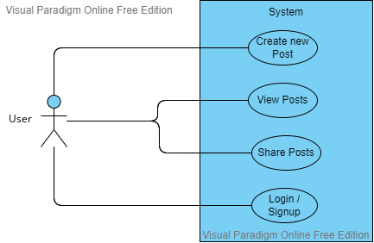

Fig1. Use Case diagram for User

The above figure depicts the use cases with which the user can interact, such as creating a new post of his choice which will be publically available and can be viewed by others globally and in the same way he can view posts made by others along with the user information who posted it. Only the relevant and non sensitive information will be displayed to the general public. The user can also share the posts within their group using WhatsApp media. In order to perform all these operation the user must register for an account and then login with the credentials in order to access the pool of information present on the website.

* **Admin**

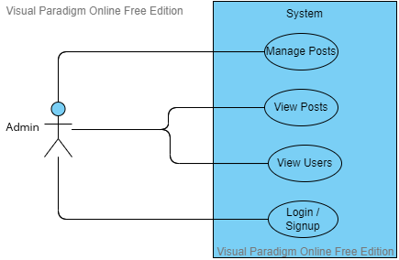

Fig2. Use Case Diagram for Admin

The admin also has certain use cases such as managing posts by performing certain operation such as deleting irrelevant and sensitive posts which doesn’t follow the platform ethics. Similar to a user the admin can also view the posts and along with this they can also view the users present on the platform. In order to access the admin privilege they must be registered as an Admin by the **Super Admin.**

* + 1. **ER Diagram**
* An entity relationship (ER) diagram is a graphical representation of the entities and relationships in a database. It is used to model the data and how they are related to each other in a database.
* An ER diagram consists of several components:
* Entities: An entity is a real-world object or concept that is represented in a database. For example, in a database for a library, entities might include books, patrons, and checkouts. Each entity is represented by a rectangular box in the ER diagram.
* Attributes: An attribute is a piece of data that describes an entity. For example, the "title" attribute describes a book entity. Attributes are represented by ovals in the ER diagram.
* Relationships: A relationship is a connection between two or more entities. For example, a "checkout" relationship connects a patron entity to a book entity. Relationships are represented by a diamond in the ER diagram.
* Cardinality: Cardinality refers to the number of entities that can be associated with a relationship. There are two types of cardinality: one-to-one (1:1), one-to-many (1:M), and many-to-many (M:M). These cardinalities are represented by lines connecting the entities and relationships in the ER diagram.
* ER diagrams are useful for visualizing and understanding the structure of a database. They can help designers create a database that is easy to use and maintain.

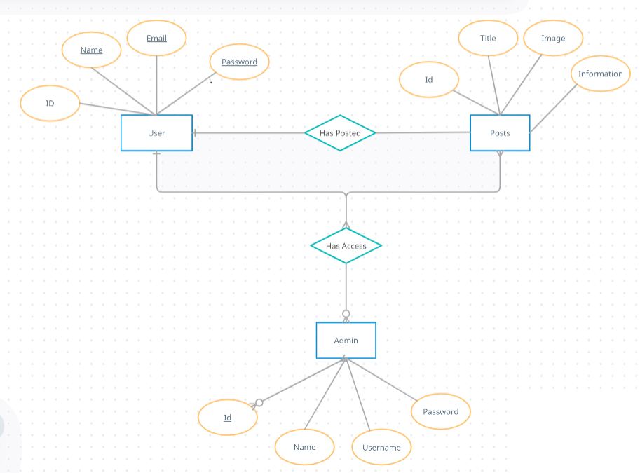

* + 1. **Database Tables**

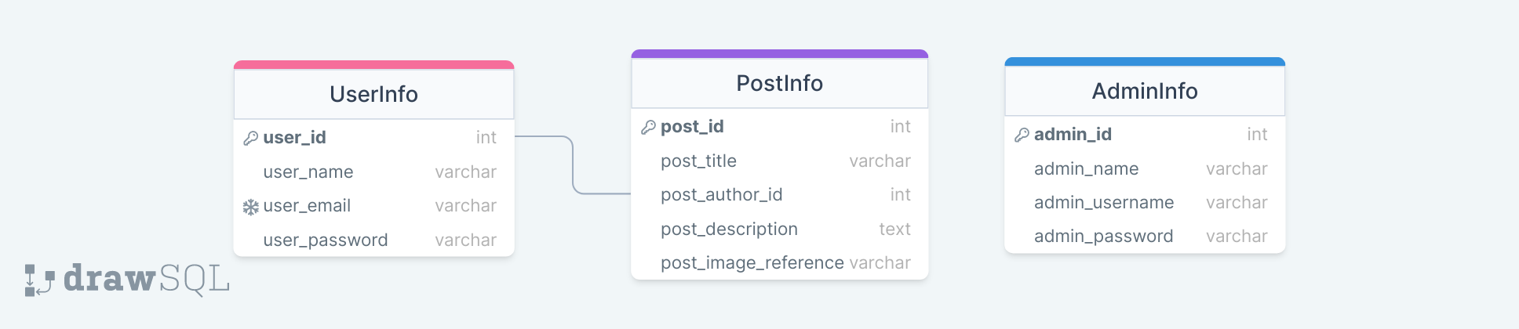

**SQL Code:**

**CREATE** **TABLE** "PostInfo"(

"post_id" INTEGER **NOT** **NULL**,

"post_title" VARCHAR(**255**) **NOT** **NULL**,

"post_author_id" INTEGER **NOT** **NULL**,

"post_description" TEXT **NOT** **NULL**,

"post_image_reference" VARCHAR(**255**) **NOT** **NULL**

);

**ALTER** **TABLE**

"PostInfo" **ADD** **PRIMARY** **KEY**("post_id");

**CREATE** **TABLE** "UserInfo"(

"user_id" INTEGER **NOT** **NULL**,

"user_name" VARCHAR(**255**) **NOT** **NULL**,

"user_email" VARCHAR(**255**) **NOT** **NULL**,

"user_password" VARCHAR(**255**) **NOT** **NULL**

);

**ALTER** **TABLE**

"UserInfo" **ADD** **PRIMARY** **KEY**("user_id");

**ALTER** **TABLE**

"UserInfo" **ADD** **CONSTRAINT** "userinfo_user_email_unique" **UNIQUE**("user_email");

**CREATE** **TABLE** "AdminInfo"(

"admin_id" INTEGER **NOT** **NULL**,

"admin_name" VARCHAR(**255**) **NOT** **NULL**,

"admin_username" VARCHAR(**255**) **NOT** **NULL**,

"admin_password" VARCHAR(**255**) **NOT** **NULL**

);

**ALTER** **TABLE**

"AdminInfo" **ADD** **PRIMARY** **KEY**("admin_id");

**ALTER** **TABLE**

"PostInfo" **ADD** **CONSTRAINT** "postinfo_post_author_id_foreign" **FOREIGN** **KEY**("post_author_id") **REFERENCES** "UserInfo"("user_id");

* + 1. **Flowcharts**
* **User Flow**

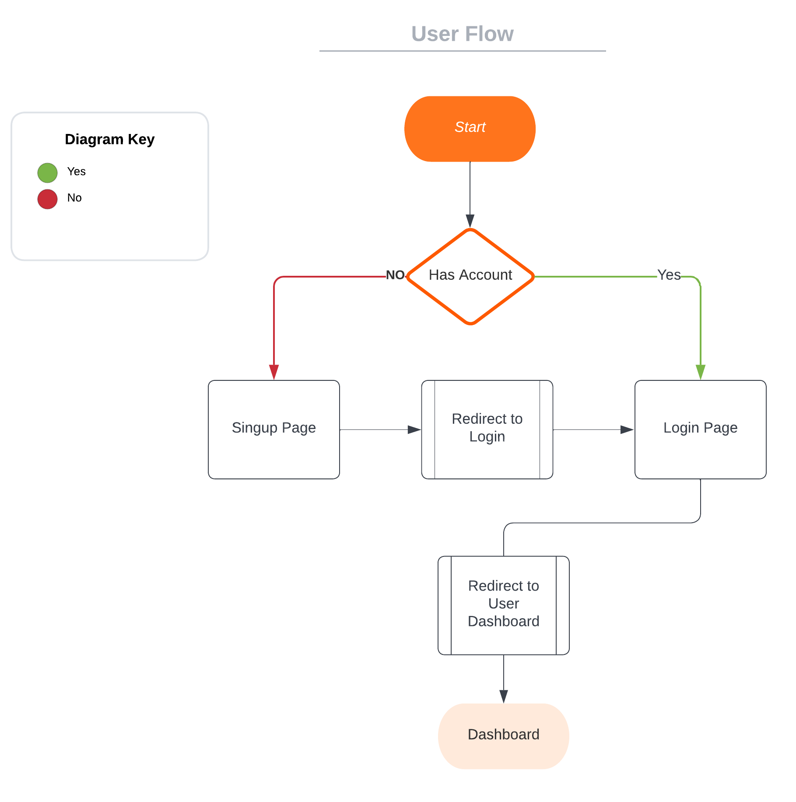

* **Admin Flow**

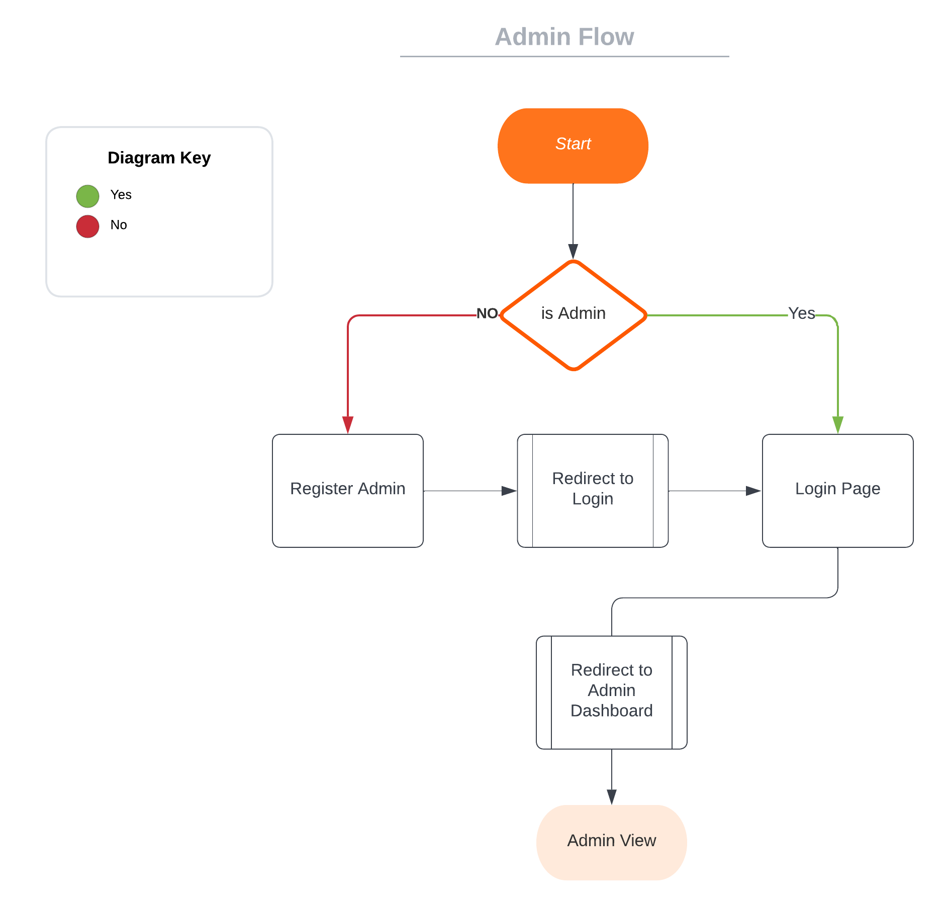

**Project Code:**

//jshint esversion:6

// Import the required packages and modules

**const** express = require("express");

**const** bodyParser = require("body-parser");

**const** ejs = require("ejs");

**const** imgur = require('imgur-uploader');

// const fs = require("fs")

**const** fileupload = require("express-fileupload");

**const** loadsh = require("lodash")

**const** session = require('express-session');

// Import the dotenv module to load environment variables from a .env file

require("dotenv").config();

// Import the async module to use asynchronous functions

**var** async = require('async');

// Import the bcrypt module to use password hashing functions

**const** bcrypt = require('bcrypt');

// Set the number of salt rounds to use when hashing passwords

**const** saltRounds = **10**;

// Create an app instance of the express web framework

**const** app = express();

// Connect to the database

**const** pg = require('pg');

**const** client = **new** pg.Client({

host: process.env.ADMIN_HOST,

user: process.env.ADMIN_USER,

port: process.env.ADMIN_PORT,

password: process.env.ADMIN_PASSWORD,

database: process.env.ADMIN_DATABASE,

idleTimeoutMillis: **0**,

connectionTimeoutMillis: **0**

});

// Connect to the database

client.connect();

// Log a message to the console when the connection is established

console.log("Connected to the database");

app.set('view engine', 'ejs'); // Set the view engine to be EJS

app.use(bodyParser.urlencoded({ extended: **true** })); // Use body-parser to parse form data

**var** urlencodedparser = bodyParser.urlencoded({ extended: **false** }) // Create a urlencoded parser

app.use(express.**static**("public")); // Serve static files from the "public" directory

app.use(fileupload()); // Use the fileupload middleware to handle file uploads

// Use the express-session middleware to manage user sessions

app.use(session({

secret: "my-secret-key", // Use a secret key to encrypt the session data

resave: **false**, // Don't resave the session if it hasn't changed

saveUninitialized: **true**, // Save a new, uninitialized session

expires: **new** Date(Date.now() + (**60** * **60** * **1000**)) // Set the session to expire after 1 hour

}));

app.get("/", **function** (req, res) {

// Check if the user is authenticated

**if** (req.session.isUserAuthenticated || req.session.isAdminAuthenticated) {

// If the user is authenticated, redirect to the home page

res.redirect('/home');

} **else** {

// If the user is not authenticated, render the signup page

res.render("signup");

}

});

app.get("/login", **function** (req, res) {

// Check if the user is authenticated

**if** (req.session.isUserAuthenticated) {

// If the user is authenticated, redirect to the home page

res.redirect('/home')

} **else** {

// If the user is not authenticated, render the login page

res.render("login")

}

})

app.get("/home", **function** (req, res, next) {

// Check if the user is authenticated

**if** (req.session.isUserAuthenticated || req.session.isAdminAuthenticated) {

// If the user is authenticated, query the database to get the post and user details

client.query(

"select p.post_id,p.post_title,p.post_description, p.post_image_reference, u.user_name from PostInfo p join UserInfo u on p.post_author_id = u.user_id ",

**function** (err, result) {

// Check for errors

**if** (err) {

// If there was an error, send a server error response

res.status(**500**).send('Error querying database: ' + err);

} **else** {

// Otherwise, render the home page with the data received from the database

**let** postDetails = result.rows;

**let** loggedUserName = req.session.isUserAuthenticated == **true** ? req.session.loggedUserName : req.session.loggedAdminName

**let** userDetails = {

userName: loggedUserName,

userEmail: req.session.loggedUserEmail,

};

res.render('home', { userDetails, postDetails });

}

}

);

} **else** {

res.redirect('/login');

}

});

**Chapter 6**

**Project Snapshots**

**6.1 Snapshot**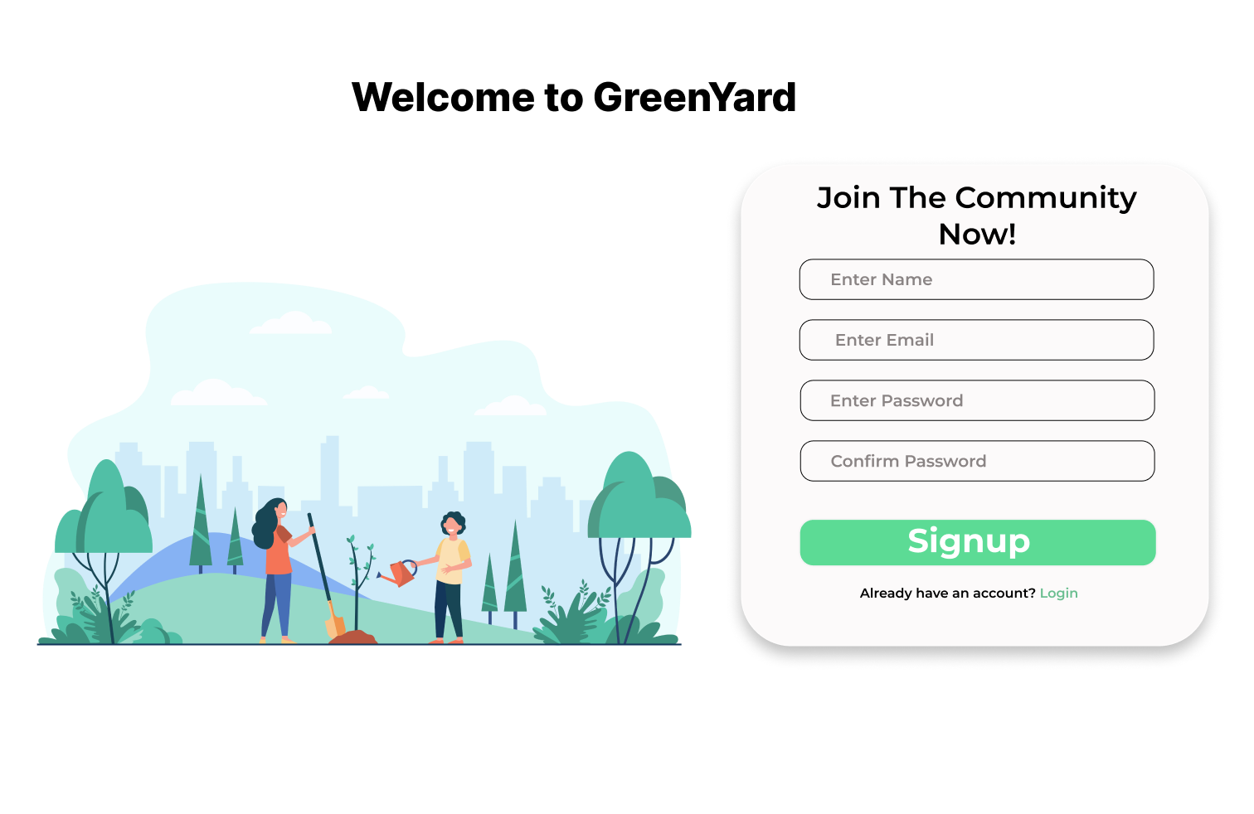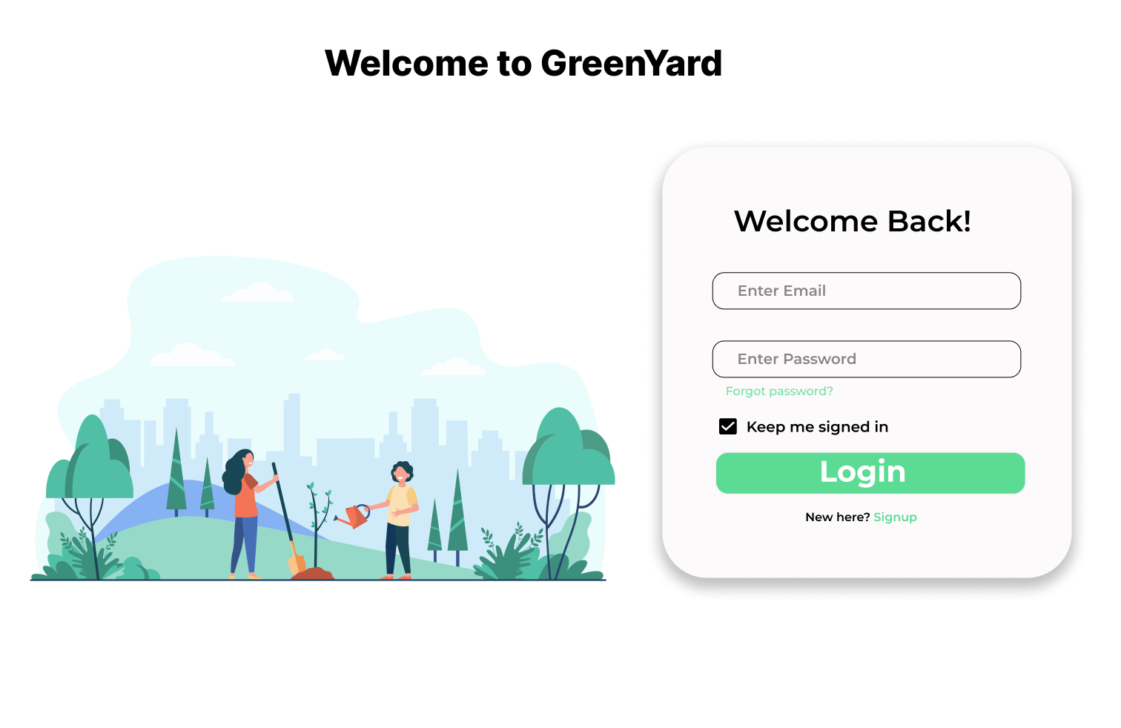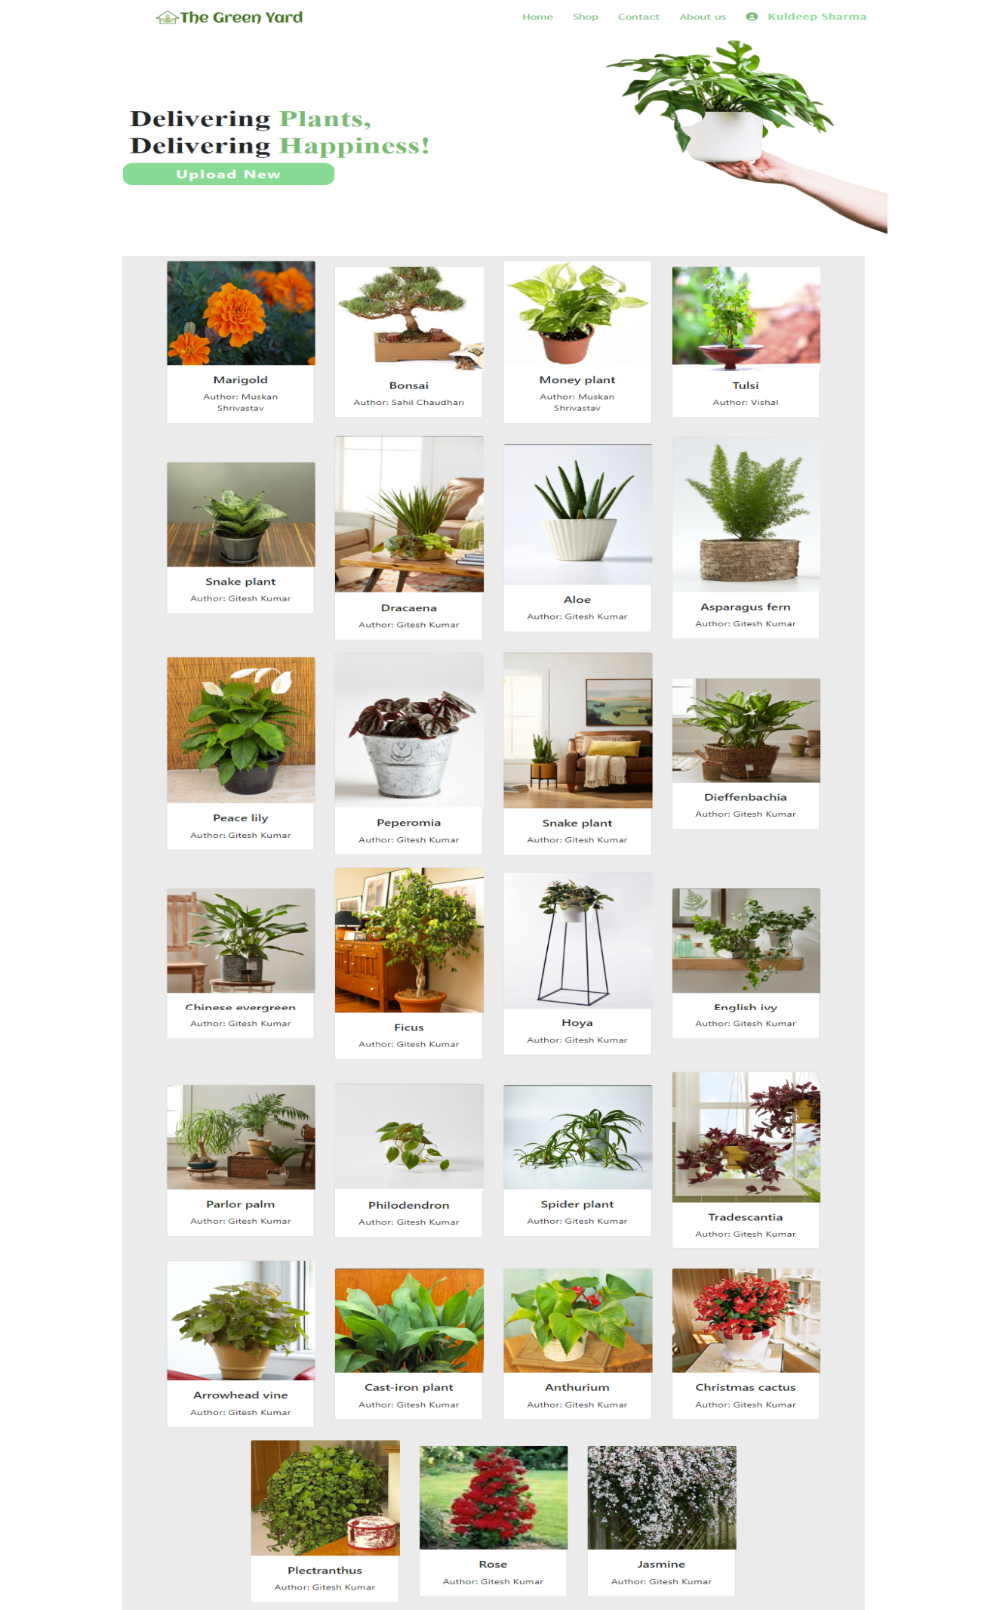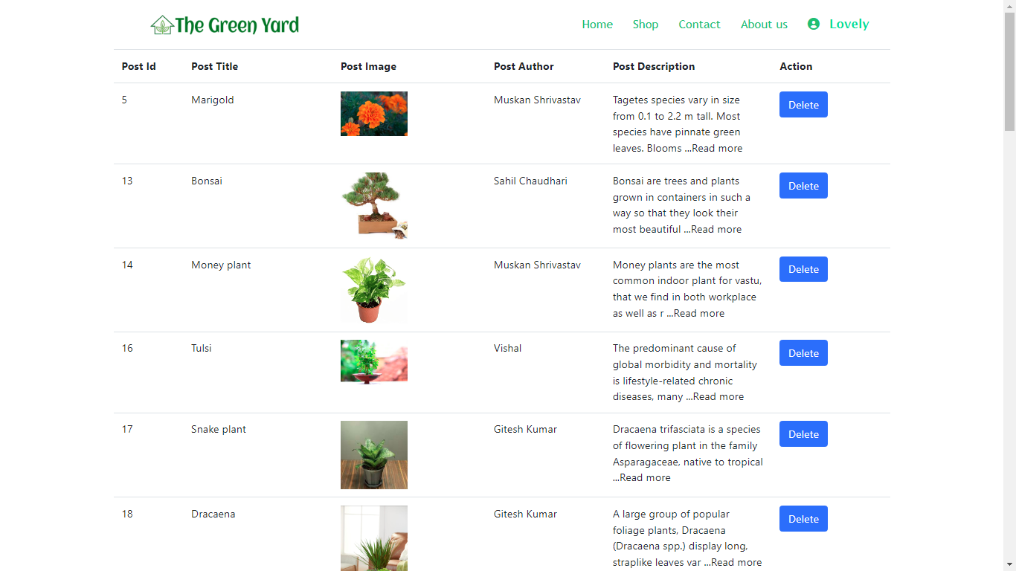

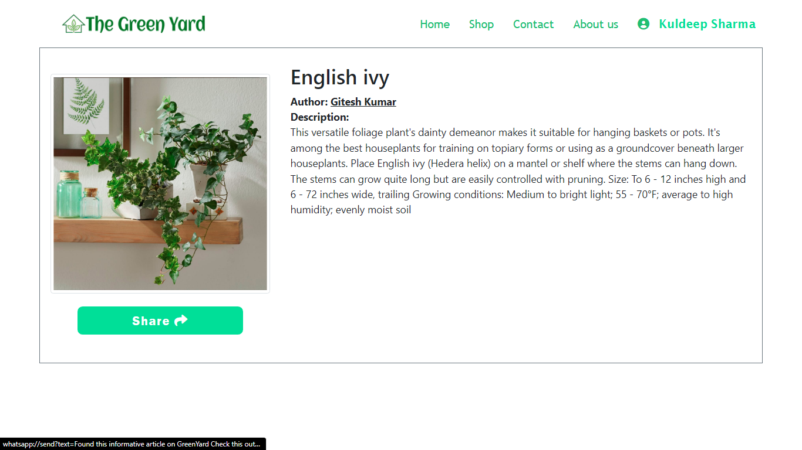

**Chapter 7**

**CONCLUSION & FUTURE SCOPE**

**7.1 Conclusion**

Our results demonstrate that gardening website users prioritize content related to plant care and gardening tips when seeking information and advice. Forum features and personalized recommendations are also highly valued. These findings can inform the development and marketing of gardening websites, ensuring that they are meeting the needs and preferences of their audience. Further research could explore the impact of these websites on gardening behaviors and the overall benefits of gardening for mental health and well-being.

**7.2 Future Scope**

The future scope for gardening web sites is to create an online platform that allows users to interact with each other, share their ideas and tips, and collaborate with other gardeners. Additionally, they could create a virtual garden that includes features such as an interactive map with plant suggestions and advice, a library of gardening resources, and a forum for users to connect and have discussions related to gardening.

The platform could also offer gardening classes and seminars hosted by experts, and provide access to tools and supplies needed to maintain a garden. In the long run, the gardening website could become an all-in-one platform for gardeners to find information and resources, and to connect with other gardeners.

In the future, gardening websites may incorporate more advanced technology such as augmented reality or virtual reality experiences. This could allow users to virtually tour gardens around the world and see how different plants look in different settings. Additionally, these websites may offer personalized garden planning services where users can input their specific gardening location, budget, and desired plants and receive a customized garden design.

The website could then connect users with local nurseries or gardening stores to purchase the recommended plants and provide ongoing support and maintenance advice. There may also be more integration with smart home technology, allowing users to remotely monitor and control their gardens through devices such as smart sprinkler systems or automated fertilization. Overall, the future of gardening websites holds the potential for even greater convenience and accessibility for gardeners of all levels.

**Chapter 8**

**HARDWARE AND SOFTWARE**

**Hardware Requirements (minimum)**

1. System : Pentium IV 2.4 GHz.

2. Hard Disk : 40 GB.

3. Floppy Drive : 44 Mb.

4. Monitor : 15 VGA Colour.

5. Ram : 512 Mb.

**Software Requirements**

1. Operating system : Windows 7+/MAC/Linux

2. IDE Used : Visual Studio Code

3. Database : PostgreSQL

4. Browser : Chrome/Edge/Firefox…

**REFERENCES**

* Bronson, F.H. 2004. "Are humans seasonally photoperiodic?" J. Biol. Rhythms 19: 180-192.
* Burchett, M., Wood, R., Orwell, R., Tarran, J., Torpy, F., and Alquezar, R. 2005. "How and why potted-plants really do clean indoor air summary." <http://www.nipa.asn.au/docs/mburchett_transcript_040305.pdf>.
* Collins, C.C., and O’Callaghan, A.M. 2008. "The impact of horticultural responsibility on health indicators and quality of life in assisted living." HortTechnol. 18:611-618.
* Darlington, A.B., Dat, J.F., and Dixon, M.A. 2001. "The biofiltration of indoor air: Air flux and temperature influences the removal of toluene, ethylbenzene, and xylene." Environ. Sci. Technol. 35:240-246.
* Dijkstra, K., Pieterse, M.E., and Pruyn, A. 2008. "Stress-reducing effects of indoor plants in the built healthcare environment: The mediating role of perceived attractiveness." Preventive Medicine 47:279-283.
* Dravigne, A., Waliczek, T.M., Lineberger, R.D., and Zajicek, J.M. 2008. "The effect of live plants and window views of green spaces on perceptions of job satisfaction." HortSci. 43:183-187.
* Fjeld, T. 2000. "The effect of interior planting on health and discomfort among workers and school children." HortTechnol. 10:46-52.
* Freeman, K. 2003. "Plants and their acoustic benefits." <http://www.plants-inbuildings.com/acoustic.php>.
* Fuller, R.A., Irvine, K.N., Devine-Wright, P., Warren, P.H., and Gaston, K.J. 2007. "Psychological benefits of greenspace increase with biodiversity." Biol. Letters 3:390-394.
* Hagerhall, C.M., Pursell, T., and Taylor, R. 2004. "Fractal dimension of landscape silhouette outlines as a predictor of landscape preference." J. Environ. Psychol. 24:247-255.
* Kaufman, A.J., and Lohr, V.I. 2008. "Does it matter what color tree you plant?" Acta Hort. 790:179-184.
* Lohr, V.I. 1992. "The contribution of interior plants to relative humidity in an office." p. 117-119. In: D. Relf (ed.), The Role of Horticulture in Human Well-being and Social Development. Timber Press, Portland, Oregon.